Grazioso Salvare Animal Shelter Dashboard
Project Overview
Author: Kelly Reinersman Course: CS-340 Client/Server Development
About the Project
What is this project?
This project is an interactive web dashboard created for Grazioso Salvare, an international rescue animal training company. The dashboard allows users to interact with and visualize data from the Austin Animal Center Outcomes database to identify dogs that are good candidates for search-and-rescue training.
What problem does it solve?
Grazioso Salvare needs to quickly identify dogs in animal shelters that meet specific criteria for different types of rescue training:
- Water Rescue
- Mountain/Wilderness Rescue
- Disaster/Individual Tracking
This dashboard provides an intuitive interface to filter, view, and analyze shelter animals based on these rescue type requirements.
What did you learn?
Through this project, I learned how to:
- Create full-stack web applications using Python
- Implement CRUD operations with MongoDB
- Build interactive dashboards using the Dash framework
- Connect front-end visualizations to back-end databases
- Apply the Model-View-Controller (MVC) design pattern

Functionality
Features
The dashboard includes the following features:
Feature | Description
Logo with Link | Grazioso Salvare logo that links to snhu.edu
Filter Options | Radio buttons to filter by rescue type
Interactive Data Table | Sortable, filterable table with pagination
Geolocation Map | Shows selected animal's location on a map
Breed Distribution Chart | Pie chart showing breed breakdown

Screenshots
Starting State (Reset - All Animals)
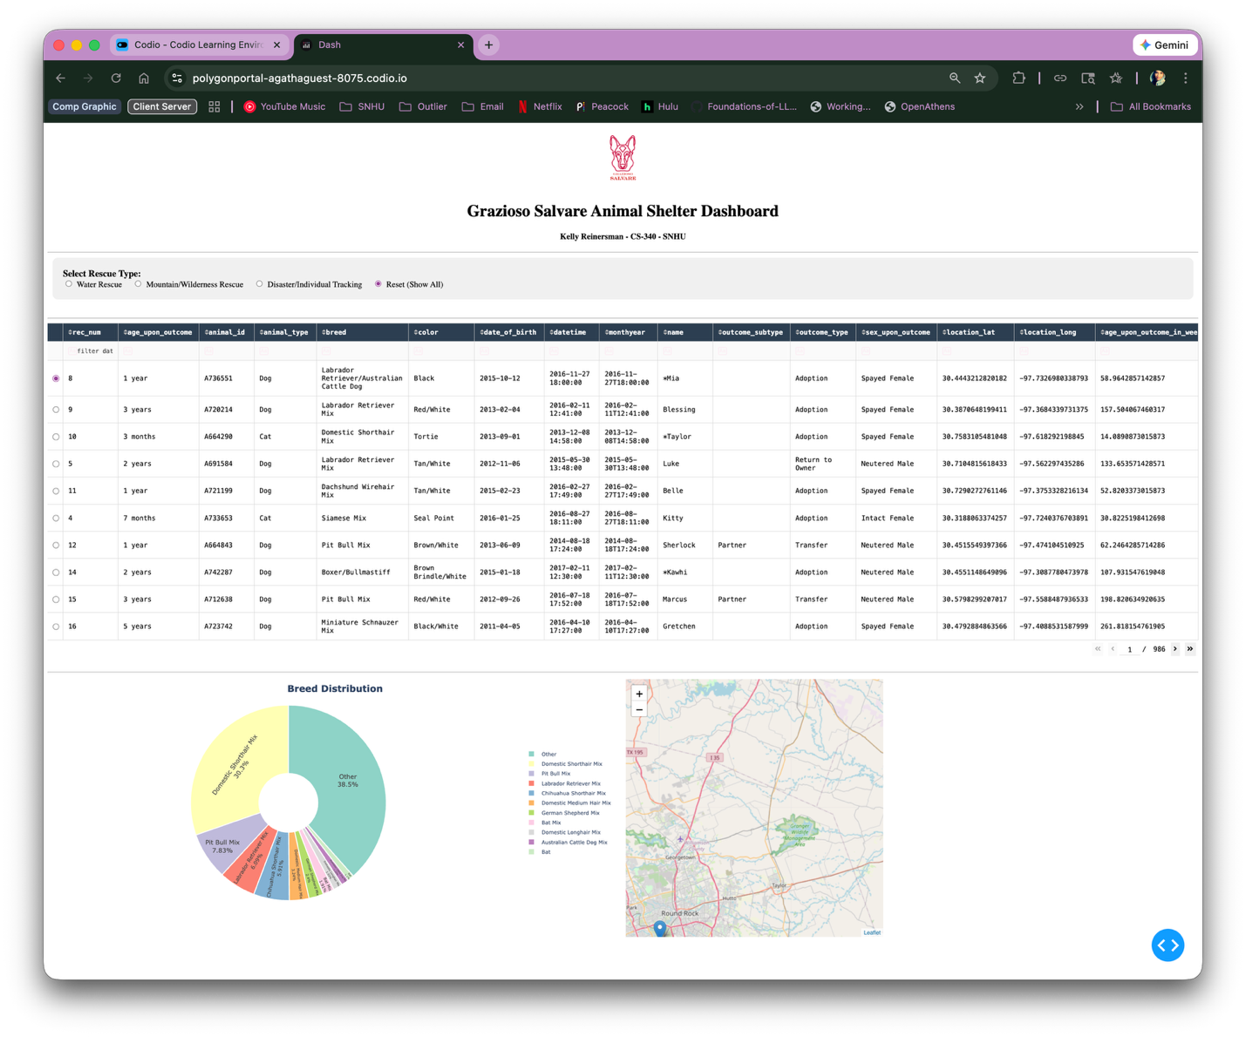

Dashboard showing all animals with no filters applied
2. Water Rescue Filter
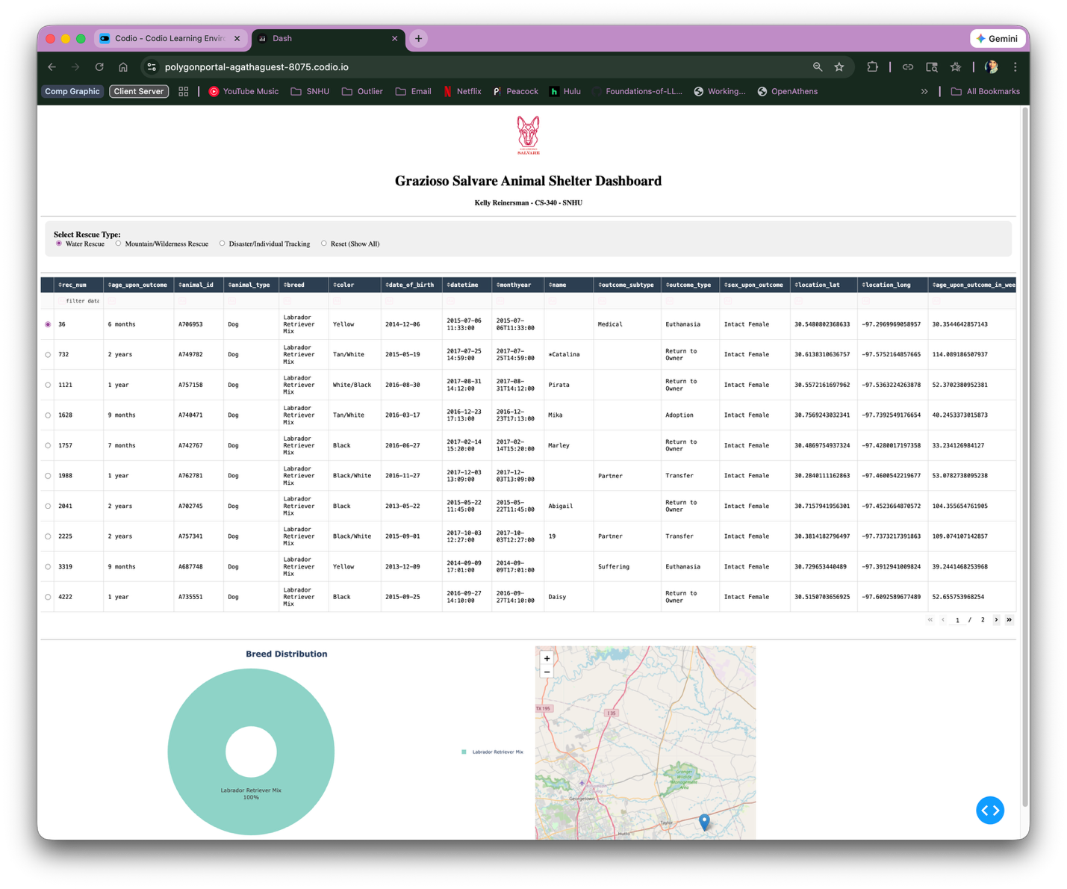

Dashboard filtered for Water Rescue candidates
3. Mountain/Wilderness Rescue Filter
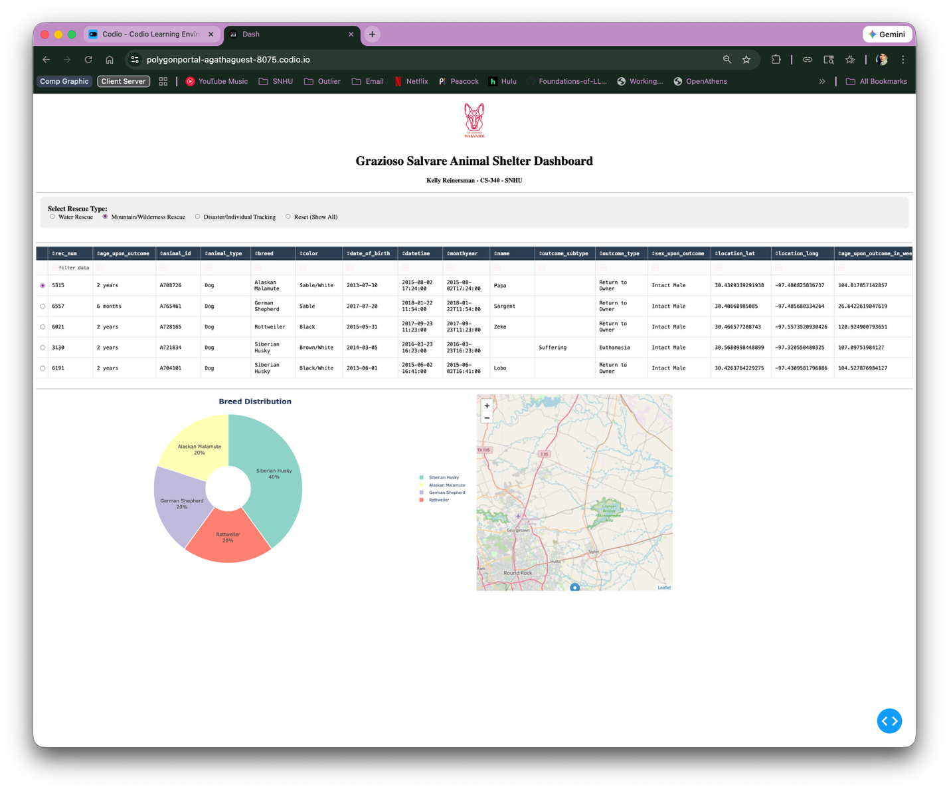

Dashboard filtered for Mountain/Wilderness Rescue candidates
4. Disaster/Individual Tracking Filter
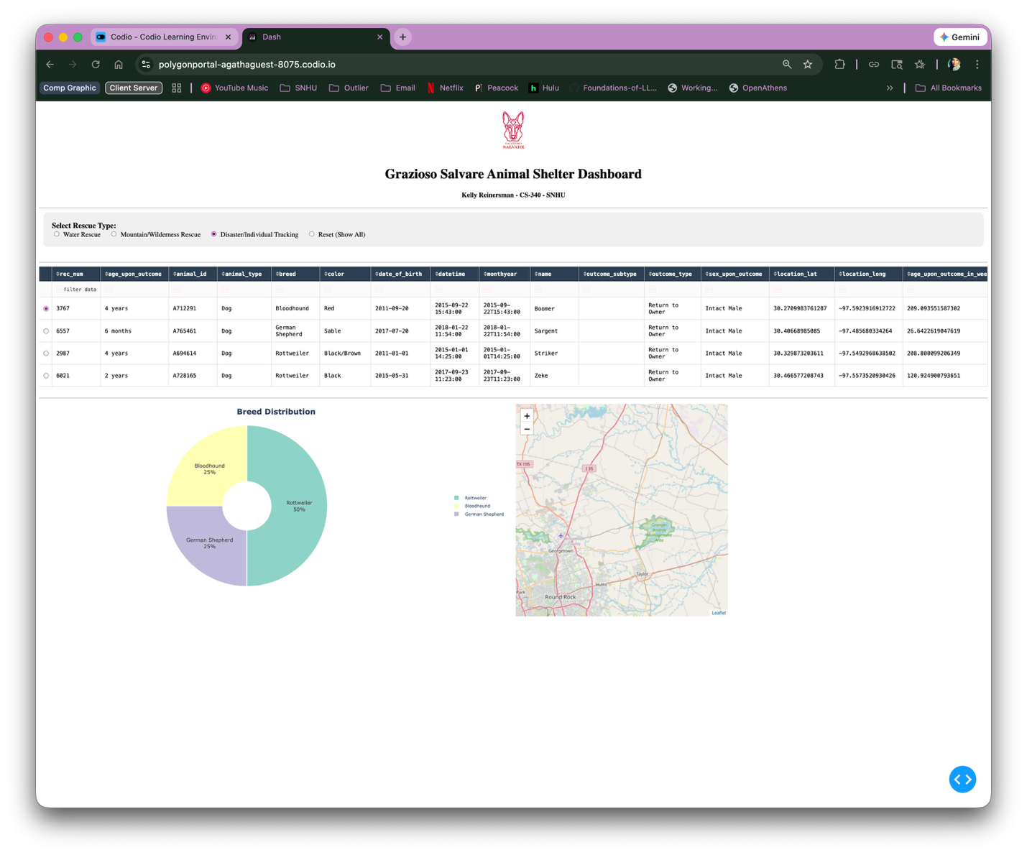

Dashboard filtered for Disaster/Individual Tracking candidates

Tools Used
MongoDB
Why MongoDB was used:
MongoDB was chosen as the database for this project because:
- Document-Oriented Structure: MongoDB stores data in flexible, JSON-like documents, which aligns well with the varied animal shelter data that includes different attributes for different animals.
- Python Integration: MongoDB integrates seamlessly with Python through the PyMongo driver, making it easy to perform CRUD operations directly from Python code.
- Scalability: MongoDB handles large datasets efficiently, which is important when working with extensive animal shelter records.
- Query Flexibility: MongoDB's query language allows for complex filtering based on multiple criteria (breed, age, sex, etc.), which is essential for identifying rescue candidates.
- Schema Flexibility: Unlike relational databases, MongoDB doesn't require a fixed schema, allowing for easy adaptation as data requirements change.
Dash Framework
Why Dash was used:
Dash was chosen as the web framework because:
- Python-Based: Dash is built on top of Flask, Plotly, and React, but allows developers to build web applications entirely in Python without needing to write JavaScript.
- Interactive Components: Dash provides built-in interactive components like data tables, dropdowns, radio buttons, and graphs that update dynamically.
- Plotly Integration: Dash integrates seamlessly with Plotly for creating interactive visualizations like pie charts and maps.
- Callback System: Dash's callback system makes it easy to create reactive applications where changes in one component automatically update others.
- MVC Architecture: Dash naturally supports the Model-View-Controller pattern:
  - Model: MongoDB database and CRUD Python module
  - View: Dashboard layout (HTML components)
  - Controller: Callback functions that handle user interactions
Additional Tools & Libraries
Tool/Library | Purpose
Python 3 | Primary programming language
PyMongo | MongoDB driver for Python
Pandas | Data manipulation and analysis
Plotly Express | Creating interactive charts
Dash Leaflet | Interactive map component
JupyterDash | Running Dash in Jupyter notebooks
Base64 | Encoding logo image for display

Steps to Complete the Project
Step 1: Set Up the Database
- Imported the Austin Animal Center Outcomes dataset into MongoDB
- Created user authentication for database access
- Verified data was properly loaded
Step 2: Develop the CRUD Python Module
- Created CRUD_Python_Module.py with the AnimalShelter class
- Implemented Create, Read, Update, and Delete methods
- Tested CRUD operations to ensure proper database connectivity
Step 3: Build the Dashboard Layout
- Designed the header with logo and identifier
- Created radio button filter options
- Set up the interactive data table with sorting and pagination
- Added side-by-side layout for chart and map
Step 4: Implement Database Queries
- Developed MongoDB queries for each rescue type:
  - Water Rescue: Labrador Retriever Mix, Chesapeake Bay Retriever, Newfoundland
  - Mountain Rescue: German Shepherd, Alaskan Malamute, Old English Sheepdog, Siberian Husky, Rottweiler
  - Disaster Tracking: Doberman Pinscher, German Shepherd, Golden Retriever, Bloodhound, Rottweiler
Step 5: Create Interactive Callbacks
- Connected filter radio buttons to data table updates
- Linked data table selection to geolocation map
- Connected data table to breed distribution chart
Step 6: Test and Deploy
- Tested all filter options
- Verified map updates correctly
- Confirmed chart displays accurate data
- Captured screenshots of functionality

Challenges and Solutions
Challenge 1: JupyterDash Communication Error
Problem: Received OSError: Unable to communicate with the jupyter_dash notebook when trying to run the dashboard.
Solution: Removed the JupyterDash.infer_jupyter_proxy_config() line from the code, which was causing communication issues in the Codio environment.
Challenge 2: Syntax Errors in Layout
Problem: Received syntax errors when adding the logo link with html.A() wrapper.
Solution: Carefully checked indentation and comma placement. Ensured the html.A() element properly wrapped the html.Img() component with correct closing brackets.
Challenge 3: Pie Chart Readability
Problem: The initial pie chart was difficult to read with too many breed categories displayed.
Solution: Modified the chart to:
- Show only the top 10 breeds
- Group remaining breeds as "Other"
- Use a donut style with better colors
- Improve legend placement and formatting
Challenge 4: Port Conflicts
Problem: Dashboard wouldn't load due to port already being in use.
Solution: Changed the port number in app.run_server() and restarted the Jupyter kernel to clear any running processes.

How to Run the Project
Prerequisites
- Python 3.x
- MongoDB server running
- Required Python packages installed
Installation
- Clone or download the project files
- Install required packages:bash pip install jupyter-dash dash dash-leaflet plotly pandas pymongo
Running the Dashboard
- Open ProjectTwoDashboard.ipynb in Jupyter Lab
- Update the username and password in the code if necessary
- Run all cells
- Click the external link provided to view the dashboard

File Structure
text
project/
│
├── ProjectTwoDashboard.ipynb # Main dashboard notebook
├── CRUD_Python_Module.py # MongoDB CRUD operations
├── Grazioso Salvare Logo.png # Company logo
├── README.md # This file
│
└── screenshots/
├── reset_state.png
├── water_rescue.png
├── mountain_rescue.png
└── disaster_tracking.png

Contact
Kelly Reinersman Southern New Hampshire University CS-340 Client/Server Development

Resources
- Dash Documentation
- MongoDB Documentation
- Plotly Express Documentation
- Dash Leaflet Documentation
- PyMongo Documentation

